**Gesture-Driven Volume Manipulation:**

**Enhancing Audio Control through Gestural Interaction**

**Ramya Rangarajan Venyaa Venkataraman Krithik Shankar P**

***School of Computer Science and Engineering School of Computer Science and Engineering School of Computer Science and Engineering***

***Vellore Institute of Technology, Chennai Vellore Institute of Technology, Chennai Vellore Institute of Technology, Chennai***

<https://github.com/ramyaranga03><https://github.com/VenyaaV> <https://github.com/krithik27>

**INTRODUCTION**

Hand gestures are one of the most common and most effective tools in Human-Computer interaction. While a plethora of devices can be used to interface with computers, hand gestures prove time and again that they are the most convenient forms of interfacing.

A gesture is defined as any nonverbal mode of communication that is intended to express one's idea. In alliance with that definition, gesture recognition is the act of identifying the movements or postures of human body parts so that computers and other electronic gadgets can be controlled. It is a fast-growing field in artificial intelligence and image processing.

The major ideology propelling research and expansion in the field of gesture recognition is the technology's ability to create an uncomplicated channel of communication between the human and the computer. Users will be able to comfortably employ hand gestures in desktop and laptop interfaces in a planned system. A perpetual user interface is a point of interaction that enables a PC system to perceive, understand and react to the normal looks, sounds, gestures, and other patterns of communication the user might encounter. A perpetual user interface includes features like gesture, facial, voice, eye tracking and lip movement detection.

Setting up a hand-tracking system is the first and most crucial stage in developing any hand gesture recognition system. The vision-based approach necessitates the use of a camera to achieve a natural connection between the user and the computer, sans the use of any gadgets. Segmentation is the process of identifying a connected area in an image that has attributes like color, intensity and a relationship between pixels. This can be achieved by using packages like OpenCV-python, MediaPipe, Comtypes, Numpy and Pycaw.

**LITERATURE REVIEW**

1. The paper "Real-time Hand Gesture Recognition Using Finger Segmentation" by Zhi-Hua Chen et al explores the importance of hand gesture recognition in human-computer interaction and also evaluates novel HCI techniques like gesture recognition. It covers the significance of hand gestures as an emotion expressor and distinguishes between a static and a dynamic hand gesture. The paper also discusses environment subtraction techniques for hand-area extraction. It also emphasizes on the utility of parameters like color, brightness, and gradient values in identifying a hand and distinguishing it from the environment. This piece of literature talks about the background needed for the successful implementation of a real-time hand motion identification technique.
2. The research paper titled "Hand Gesture Recognition Using Particle Swarm Movement" by Clementine Nyirarugira et al. explores the different methods for hand gesture detection, such as Particle Swarm Optimization(PSO), Dynamic Time Warping(DTW) and hidden Markov models (HMM). By comparing the PSO-based approach to the current day methods, this paper hopes to bring to light the difficulties in hand gesture detection and the need for real-time applications. The literature postulates a thorough overview of the most recent techniques for dynamic hand gesture detection, emphasizing the significance of accurate recognition rates and reduced processing times.
3. The paper, "A review of the Hand Gesture Recognition System: Current Progress and Future Directions'' by Noraini Mohamed et al. makes a comprehensive survey of a thorough review of the literature covering image based hand gesture recognition research from 2014 to 2020. It emphasizes on hand gesture representation, the environment data, and the collection of data. The review paper focuses on the need for a reliable signer-independent recognition system and the complications involved in continuous sign language detection. It also makes a comparison between the accuracy of signer-based and non signer-based recognition systems. The paper also summarizes the constraints in gesture detection and the paths for advancement in the future.
4. The paper "A Novel Multi-Camera System for High-Speed Touchless Palm Recognition" by Xu Liang et al. summarizes the significance of metaheuristic algorithms like PSO, GWO, ABC, and WOA in tackling real-world issues. It brings to light the advancement of hybrid algorithms, which aggregate several metaheuristic approaches to improve the effectiveness of solving problems. The literature also highlights the utility of these algorithms in various sectors, demonstrating their efficiency in optimizing tasks. It highlights the significance of metaheuristic algorithms in optimizing computation and lays the foundation for the hybrid deep-learning model.
5. The literature "Hand Gesture Recognition Using Modified 1$ and Background Subtraction Algorithms" by Hazem Khaled et al. summarizes the value of hand gesture recognition as opposed to Human-Computer Interaction methods. It evaluates several ways to recognize hand gestures. Some of these methods include appearance-based and three-dimensional hand model-based techniques. The paper also emphasizes on the constraints concerning background subtraction algorithms and the importance of skin coloration and form in hand gesture identification. It also summarizes the current methods and their efficiency in real time gesture detection. The paper provides a thorough analysis of the methods that are already being used and lays the basement for possible future areas of research.

**PROPOSED METHOD**

We make use of Python for this project: OpenCV and NumPy modules will be used in the Python code which is to be built and designed. Any libraries needed for additional input and output processing are initially imported into the project. The following libraries need to be imported into this particular project: MediaPipe, math, PyCaw, OpenCV, and Numpy. Video inputs are received from our system camera.

Here, the video is detected using the MediaPipe library as the input from the camera, and the gesture is detected using mphand.hands module. We utilized the PyCaw to access the speaker, and we specified the volume range, ranging from the lowest volume to the highest volume. We use PyCaw to access the speaker, and we specified the volume range, ranging from the lowest to the highest volume. To finish processing the input recorded, the next step is to transform the input image to an RGB image. The next task is to indicate the input and the finger points of the thumb. Numpy is used to transform the volume range that is processed utilizing the hand range and process the output. NumPy is a core Python package that is used for computations.

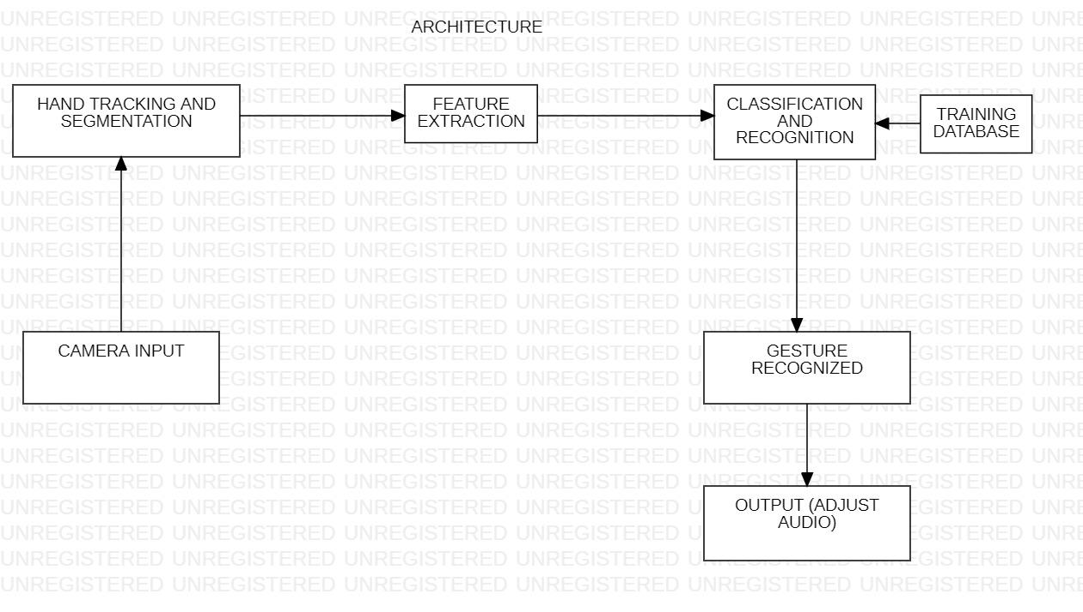

1. **OpenCV**

OpenCV is a Python package that tackles problems in computer vision. It is used for face detection, which is achieved using machine learning. It is a very significant library that supports multiple programming languages and is used to detect multiple frames and detect faces. It also has motion and object detection capabilities. It may also be used to recognize animal faces and supports a variety of operating systems.

1. **Numpy**

Numerical Python, or NumPy, also referred to as an extension module, is essentially written in the C language. NumPy promises exceptional speed of execution. The main uses of NumPy are for calculations and operations involving some of its functions, such as power, divide and multiply.

1. **Histogram - Image Filtering**

A histogram is a kind of graph that shows how the strength of the pixels move during a depiction. In order to process the image in our system, we use the histogram to filter the photos and then convert them to RGB. As a result, the pixel's power falls between [0-255].

1. **MediaPipe**

MediaPipe is a module that processes audio, video, and several associated datatypes on platforms like Android, iOS, web edge devices and various application machine learning pipelines. This module can be used to accomplish a variety of tasks. In this particular project, it was used to identify hand gestures and extract information from them.

* Face Recognition
* Multiple Hands Tracking
* Object Detection and Tracking
* Segmentation

The constraint of dealing with these systems is dealing with background images or videos that are filmed or captured while the user is making hand gestures. In addition, lighting can occasionally affect the quality of input, making it difficult to recognize movements.

**DATABASE**

Hand tracking and landmarks detection is done using the MediaPipe library in this application. Therefore, it does not involve any direct interaction with a database. Rather, it makes use of computer vision and audio control libraries to perform real-time hand gesture recognition and adjusts the system volume accordingly.

Following the capturing of video frames from the webcam, MediaPipe is used to hand track and detect the landmarks. It also calculates the distance between the thumb and the index finger and adjusts the volume based on this distance. PyCaw is used to interact with the Windows Audio API and control the system volume accordingly.

**REFERENCES**

1. Zhi-hua Chen, Jung-Tae Kim, Jianning Liang, Jing Zhang, Yu-Bo Yuan, "Real-Time Hand Gesture Recognition Using Finger Segmentation", *The Scientific World Journal*, vol. 2014, Article ID 267872, 9 pages, 2014.
2. Clementine Nyirarugira, Hyo-rim Choi, TaeYong Kim, "Hand Gesture Recognition Using Particle Swarm Movement", *Mathematical Problems in Engineering*, vol. 2016, Article ID 1919824, 8 pages, 2016.
3. N. Mohamed, M. B. Mustafa and N. Jomhari, "A Review of the Hand Gesture Recognition System: Current Progress and Future Directions," in IEEE Access, vol. 9, pp. 157422-157436, 2021, doi: 10.1109/ACCESS.2021.3129650.
4. X. Liang, D. Zhang, G. Lu, Z. Guo and N. Luo, "A Novel Multi Camera System for High-Speed Touchless Palm Recognition," in IEEE Transactions on Systems, Man, and Cybernetics: Systems, vol. 51, no. 3, pp. 1534-1548, March 2021, doi: 10.1109/TSMC.2019.2898684.
5. Hazem Khaled, Samir G. Sayed, El Sayed M. Saad, Hossam Ali, "Hand Gesture Recognition Using Modified 1$ and Background Subtraction Algorithms", *Mathematical Problems in Engineering*, vol. 2015, Article ID 741068, 8 pages, 2015.